

**Product Dissection for Groww**

### **Company Overview:**

Groww is a financial technology company founded in 2016 by Lalit Keshre, Harsh Jain, Ishan Bansal, and Neeraj Singh, former employees of Flipkart, with a vision to simplify investing for the masses. The platform was officially launched in 2017 and has since become one of the leading investment platforms in India, offering a range of financial products such as mutual funds, stocks, ETFs, digital gold, and more.

**Founders:**

* **Lalit Keshre (CEO):** Lalit oversees the product and customer experience at Groww. Prior to Groww, he was in a senior product management role at Flipkart and has also founded an online learning company called Eduflix.
* **Harsh Jain (COO):** Harsh leads Growth and Business at Groww. He was previously part of the product management team at Flipkart and has co-founded a story-telling start-up.
* **Neeraj Singh (CTO):** Neeraj heads product development and customer research at Groww. He was with Flipkart as an engineering manager before co-founding Groww.
* **Ishan Bansal (CFO):** Ishan heads Finance at Groww. He has worked in corporate development at Flipkart and Naspers before joining Groww.

**Company History:** Groww was founded based on the founders' own experiences and observations of the complexities involved in investing in financial products in India. They aimed to simplify the investment process and make it more accessible to a wider audience. Groww started as a direct mutual fund distribution platform in 2017 and quickly gained popularity, becoming one of the most popular mutual fund investment platforms in India within a year.

**Product Offerings:** Over the years, Groww has expanded its product offerings to include stocks, digital gold, ETFs, Intraday trading, IPOs, and more, catering to the diverse investment needs of its users. The platform has gained the trust of over 1.5 crore users across 900+ cities in India, showcasing its rapid growth and widespread adoption.

**Funding Details:** Groww has received funding from some of the most respected investors in the fintech space, reflecting confidence in its vision of democratizing investing in India. The company has raised several rounds of funding, with the latest being a Series E round in October 2021, led by ICONIQ Growth, valuing the company at $3 billion.

**Product Dissection:**

Groww, a leading investment platform in India, offers a range of financial products and services to simplify investing for its users. Here's a dissection of Groww key features and how they solve real-world problems:

* **User-Friendly Interface:** Groww platform is designed to be intuitive and easy to use, even for first-time investors. The simple interface guides users through the investment process, eliminating the complexities often associated with investing.
* **Mutual Funds:** Groww allows users to invest in a wide range of mutual funds, including equity, debt, and hybrid funds. Users can choose funds based on their investment goals and risk tolerance, making it easier to build a diversified portfolio.
* **Stocks:** Groww offers a platform for users to invest in stocks listed on BSE and NSE . The platform provides essential information and tools to help users make informed investment decisions.
* **Digital Gold:** Groww enables users to invest in digital gold, offering a convenient and secure way to invest in gold without the need for physical storage.
* **ETFs:** Groww provides access to Exchange-Traded Funds (ETFs), allowing users to invest in a diversified portfolio of securities with a single investment.
* **Intraday Trading:** Groww offers an intraday trading feature, allowing users to buy and sell stocks within the same trading day, potentially capitalizing on short-term price movements.
* **IPOs:** Groww provides access to Initial Public Offerings (IPOs), enabling users to invest in newly listed companies.
* **Education and Research:** Groww offers educational resources and research tools to help users learn about investing and make informed decisions.

**Real-World Problems Solved by Groww:**

1. **Complexity of Investing:**
   * **Problem:** Investing in financial products can be complex and intimidating for many people.
   * **Solution:** Groww offers a user-friendly interface and comprehensive educational resources to simplify the investment process, making it more accessible to a wider audience.
2. **Lack of Awareness:**
   * **Problem:** Many people are unaware of the various investment options available to them.
   * **Solution:** Groww platform educates users about different investment products, helping them make informed decisions based on their financial goals.
3. **Limited Access for Small Investors:**
   * **Problem:** Traditional investment platforms often require a minimum investment amount, making it difficult for small investors to participate.
   * **Solution:** Groww allows users to start investing with as little as ₹100, making investing more accessible to everyone.
4. **Security and Convenience of Physical Assets:**
   * **Problem:** Investing in physical assets like gold can be cumbersome and risky due to storage and security concerns.
   * **Solution:** Groww digital gold feature offers a secure and convenient way to invest in gold without the need for physical storage.
5. **Challenges in Diversification:**
   * **Problem:** Building a diversified investment portfolio can be challenging for individual investors.
   * **Solution:** Groww platform offers a range of investment options, including mutual funds, stocks, ETFs, and more, helping users build a diversified portfolio tailored to their needs.

### **Top Features of Groww:**

* **User-Friendly Interface:** Groww platform is designed to be intuitive and easy to use, even for beginners. The interface provides a seamless investing experience, guiding users through the process step by step.
* **Wide Range of Investment Options:** Groww offers a variety of investment options, including mutual funds, stocks, ETFs, digital gold, and more. This allows users to build a diversified portfolio based on their investment goals and risk tolerance.
* **Educational Resources:** Groww provides educational resources, including articles, tutorials, and videos, to help users learn about investing. This empowers users to make informed decisions and manage their investments effectively.
* **Goal-Based Investing:** Groww allows users to set investment goals, such as saving for retirement or buying a house, and helps them create a customized investment plan to achieve those goals.
* **Paperless KYC:** Groww offers a paperless KYC (Know Your Customer) process, making it quick and easy for users to complete their KYC requirements and start investing.
* **Auto-Invest:** Groww's auto-invest feature allows users to set up automated investments at regular intervals. This helps users stay disciplined with their investments and take advantage of rupee-cost averaging.
* **Portfolio Tracking:** Groww provides tools to track the performance of users' investment portfolios. Users can see their portfolio's growth over time and make adjustments as needed.
* **Customer Support:** Groww offers customer support through various channels, including chat, email, and phone. This ensures that users can get assistance with their investments whenever they need it.
* **Secure Platform:** Groww prioritizes the security of its users' investments and personal information. The platform uses encryption and other security measures to protect user data.
* **Low Fees:** Groww charges low fees for its services, making investing more affordable for users. This allows users to keep more of their investment returns.

### **Schema Description:**

The schema defines the structure of a database for a financial investment platform, including tables for Orders, Users, and Instruments. Orders table tracks order details, Users table stores user information, and Instruments table contains details about financial instruments. Each table has unique identifiers for efficient data management and retrieval.

### **Orders Table**

* **order_id:** (Primary Key) Unique identifier for each order.
* **user_id:** Identifier for the user placing the order. (Foreign Key referencing Users table)
* **order_type:** Type of order (e.g., buy, sell).
* **order_status:** Status of the order (e.g., pending, completed, canceled).
* **order_date:** Date and time when the order was placed.
* **instrument_id:** Identifier for the specific financial instrument. (Foreign Key referencing Instruments table)
* **quantity:** Number of units or shares of the instrument.
* **price:** Price at which the order was executed (if applicable).
* **total_amount:** Total amount of the order (quantity * price).
* **payment_status:** Payment status of the order (e.g., paid, pending).
* **payment_method:** Payment method used for the order (e.g., bank transfer, UPI).
* **created_at:** Timestamp for when the order record was created.
* **updated_at:** Timestamp for when the order record was last updated.

### **Users Table**

* **user_id:** (Primary Key) Unique identifier for each user.
* **name:** Name of the user.
* **email:** Email address of the user.
* **phone_number:** Phone number of the user.
* **created_at:** Timestamp for when the user account was created.
* **updated_at:** Timestamp for when the user account was last updated.

### **Instruments Table**

* **instrument_id:** (Primary Key) Unique identifier for each financial instrument.
* **instrument_name:** Name or symbol of the financial instrument.
* **instrument_category:** Category of the financial instrument (e.g., mutual fund, stock, ETF).
* **created_at:** Timestamp for when the instrument record was created.
* **updated_at:** Timestamp for when the instrument record was last updated.

**Relationships are:**

* **User**:
  + One user can place many orders.
  + One user can provide many feedback entries.
  + One user can submit many reports.
* **Stock, MutualFund, ETF**:
  + Each order can include one or more stocks, mutual funds, or ETFs.
* **Order**:
  + Each order is placed by one user.
  + Each order affects one account.
  + Each order is executed by one broker.
  + Each order has one buyer and one seller.
* **Account**:
  + Each account belongs to one user.
  + Each account can be affected by many orders.
* **Feedback**:
  + Each feedback entry is given by one user.
* **Report**:
  + Each report is submitted by one user.

**ER Diagram:**

Let's construct an ER diagram that vividly portrays the relationships and attributes of the entities within the Groww schema. This ER diagram will serve as a visual representation, shedding light on the pivotal components of Instagram's data model. By employing this diagram, you'll gain a clearer grasp of the intricate interactions and connections that define the platform's dynamics

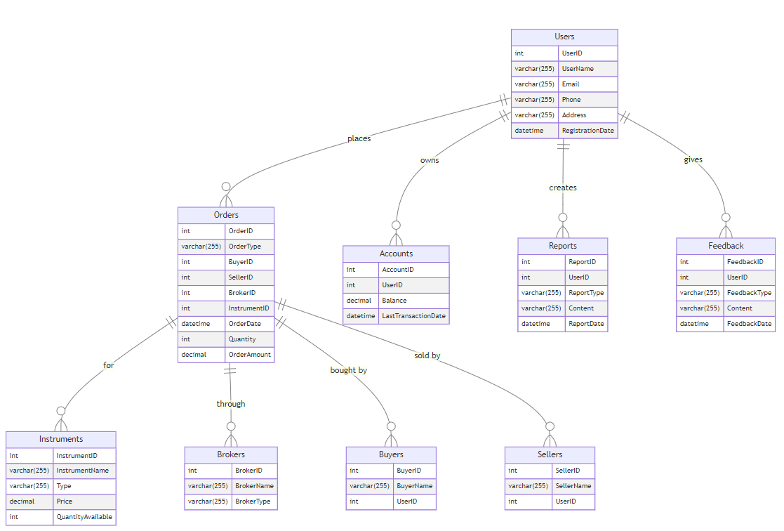

**Conclusion:**

The ER diagram for Groww clearly illustrates how the platform manages user data, financial transactions, and broker interactions. This structure helps Groww achieve its goal of making investing simple and accessible.

By including essential features like brokers, feedback systems, and detailed user account management, Groww can meet diverse user needs while ensuring efficiency and regulatory compliance. This case study highlights how a well-designed ER diagram is crucial for Groww growth and success in the Indian fintech industry.

Presentation Video:

Github : https://github.com/nick142k/Case-Study-of-Groww

Contribution: Individual

Email: nikhil.rgp007@gmail.com